ABC MANUFACTURING
BUDGET VARIANCE DASHBOARD

Submitted by:
Name: S.SHERENE
Roll no: E25FA067
Department: B.Com FinTech and AI
Year of Study: 2nd Year
Introduction
For this project, I analysed ABC Manufacturing’s budget and actual operating figures for April, May, and June 2026. The dataset contains planned and actual units sold, selling prices, variable production costs per unit, and monthly fixed costs. These fields make it possible to compare planned performance with actual results and identify where favourable or adverse variances occurred.
The purpose of the dashboard is to turn the spreadsheet into a clear, interactive management view. By comparing revenue, costs, units sold, and profit across the three months, a user can quickly see whether performance is above or below budget. The figures and observations in this report are calculated from the supplied Excel dataset; dashboard visuals are presented as report-ready designs for Power BI.
Objectives
- Compare budgeted and actual sales revenue for each month.
- Measure differences between budgeted and actual units sold.
- Compare variable production costs and fixed operating costs.
- Calculate budgeted profit, actual profit, and profit variance.
- Present monthly performance using clear charts and KPI cards.
- Make the report easier to explore through month-based filtering.
Dataset Description
The workbook contains a BudgetVarianceData sheet with three monthly records and a FieldGuide sheet describing the columns. The reporting period covers April 2026 to June 2026.
- Month and MonthStart — reporting month label and month-start date.
- BudgetedUnits and ActualUnitsSold — planned units and units actually sold.
- BudgetedSellingPrice and ActualSellingPrice — planned and actual selling price per unit, in INR.
- Budgeted and Actual Material Cost per Unit — direct material cost per unit.
- Budgeted and Actual Labour Cost per Unit — direct labour cost per unit.
- Budgeted and Actual Variable Overhead per Unit — variable overhead per unit.
- Budgeted and Actual Factory Rent, Salaries, Advertising, and Other Fixed Costs — monthly fixed operating costs.
Data Preparation
The following preparation steps are appropriate before building the dashboard in Power BI:
- Import the Excel workbook and select the BudgetVarianceData sheet.
- Set MonthStart to the Date data type and retain Month as the display label.
- Check that units are whole numbers and all price and cost fields are numeric currency values in INR.
- Create calculated measures for revenue, variable costs, fixed costs, profit, and variances.
- Check the monthly totals against the source rows before building the visuals.
The supplied workbook has three monthly rows. It does not include a separate transaction-level table, product category, or factory/department identifier, so the analysis is limited to the monthly figures provided.
Measures and KPIs
The dashboard includes five main DAX measures:
➢ Total Revenue — summarises the total revenue generated from sales in the current selection.
➢ Total Profit — shows the total profit earned from sales.
➢ Total Orders — summarises the number of orders recorded in the data.
➢ Total Quantity — shows the total quantity of products sold.
➢ Average Order Value — calculates the average revenue generated per order.
Dashboard Components
Cards
The Retail Sales Dashboard includes cards for Total Revenue, Total Profit, Total Orders, and Total Quantity. Together, these provide a quick summary of sales value, profitability, order volume, and units sold.
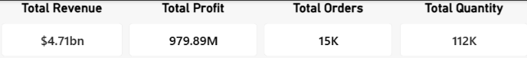

Revenue by Product Category
A clustered column chart compares revenue across product categories. It helps identify categories that contribute more or less to overall revenue.
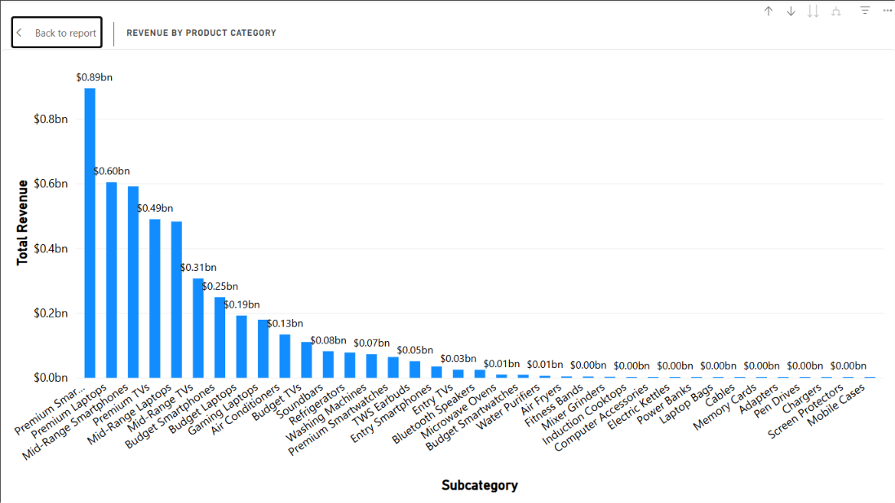
Profit by Product Category
A treemap displays profit by product category. The relative size of each category makes it easier to compare its contribution to profit at a glance.
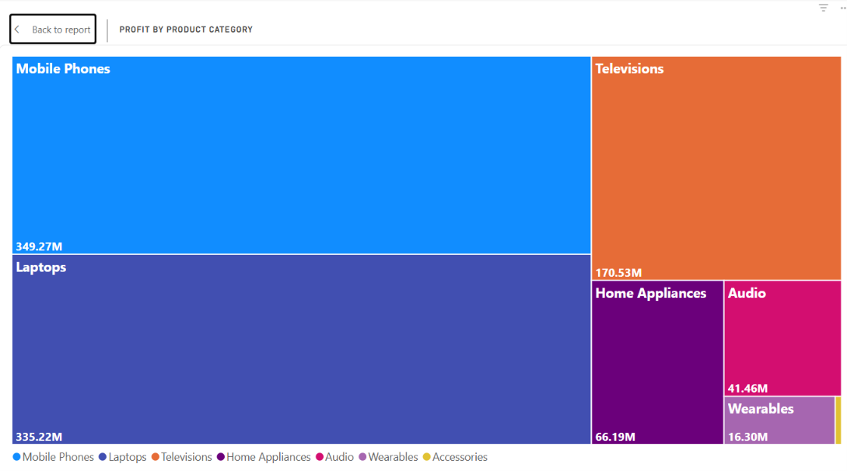

Revenue by Store
A clustered bar chart compares revenue across stores, supporting store-level performance review and the identification of differences between locations.
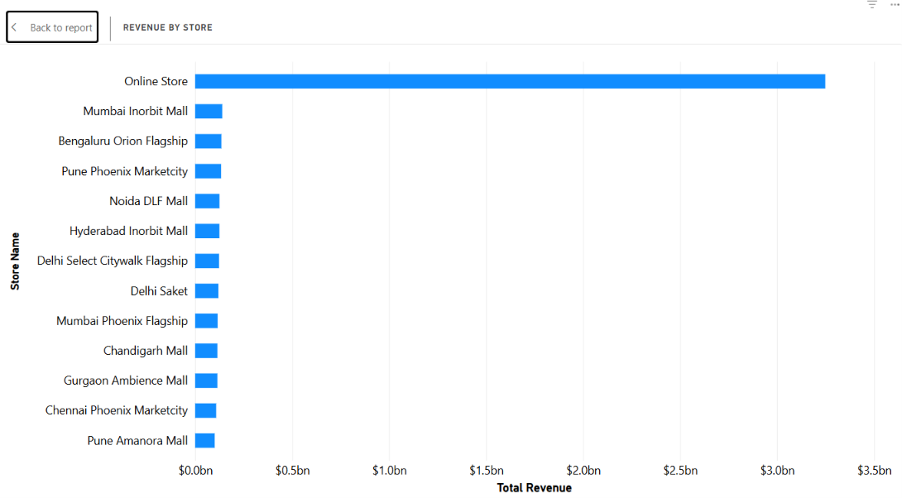
Monthly Revenue Trend
A line chart plots revenue by year and month, making changes over time visible and supporting month-to-month and seasonal comparisons where the data permits.
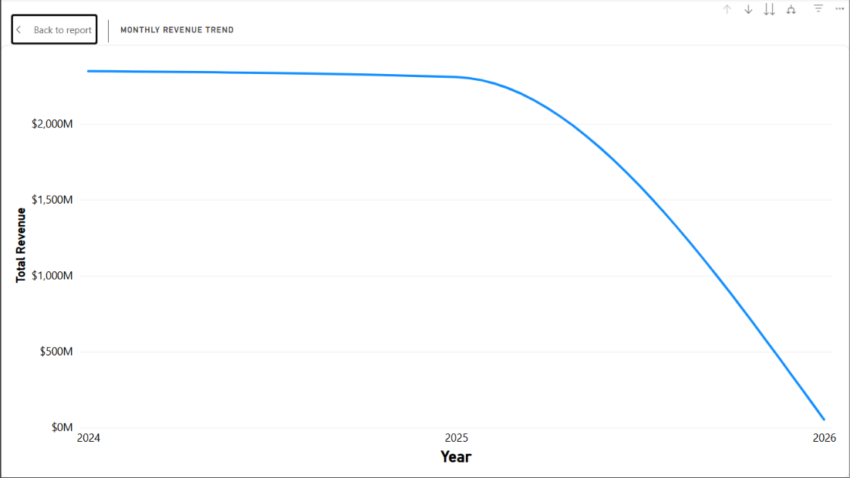

Revenue Distribution by Store Type
A donut chart shows how total revenue is distributed across store types. This provides a proportion-based view alongside the more detailed store comparison.
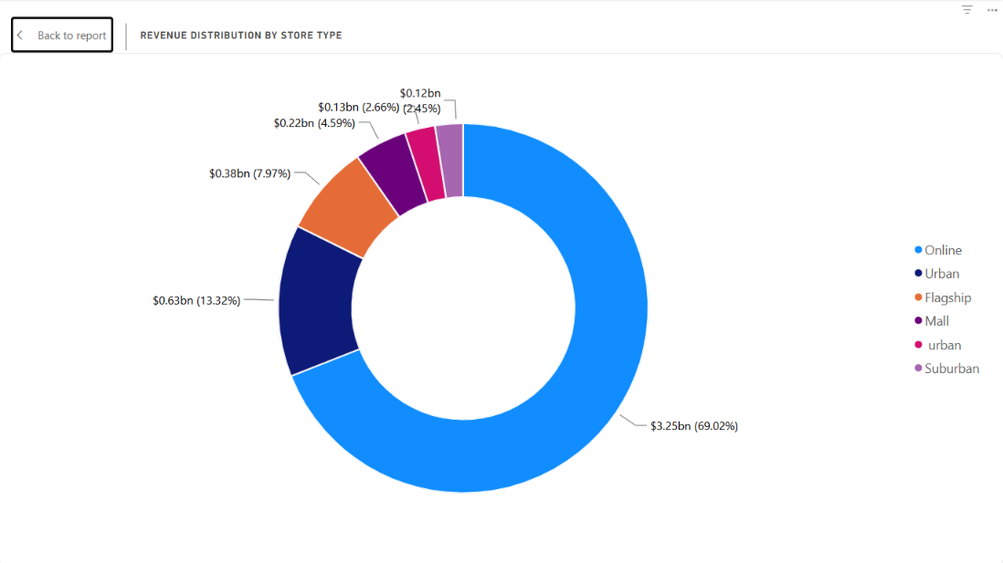
Revenue by City
A clustered bar chart compares revenue across cities, helping users review geographic differences in sales.
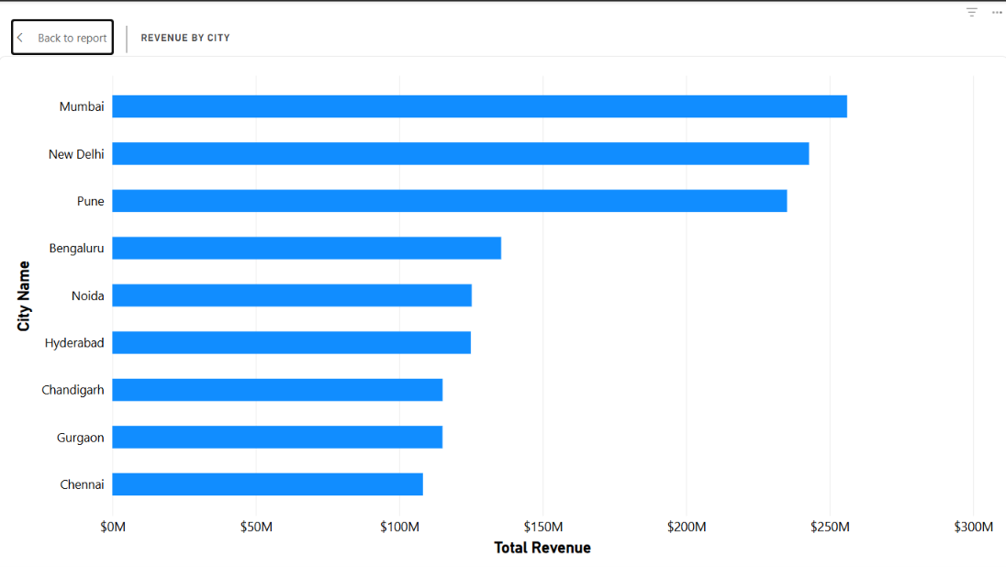

Store Performance Table
A table titled Store Performance combines store-related fields with revenue and profit measures to support a more detailed comparison than the summary charts alone.
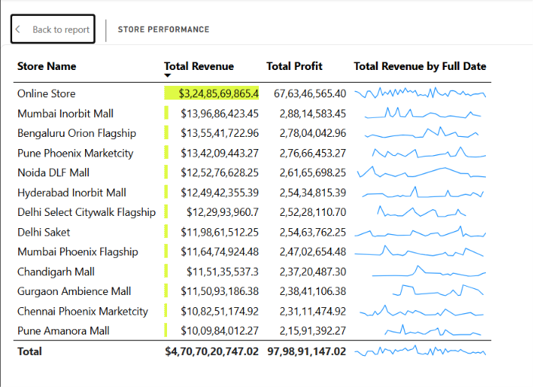
Slicers and Interactivity
The PBIX includes slicers for several dimensions, including store, customer segment, salesperson, year, month, state, city, product category, and store type. These controls allow the user to narrow the dashboard to a selected group and review how the KPIs and charts respond. The exact interaction behavior should be tested in Power BI Desktop, particularly where visual interactions have been customized.
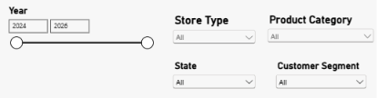
Tooltip
The Store Type Tooltip provides additional information about revenue generated by each store type when the user hovers over the chart. It helps users understand the revenue contribution of different store types. This makes it easier to compare store types and identify which contributes more to overall sales. The tooltip offers quick insights without overcrowding the dashboard with extra details.
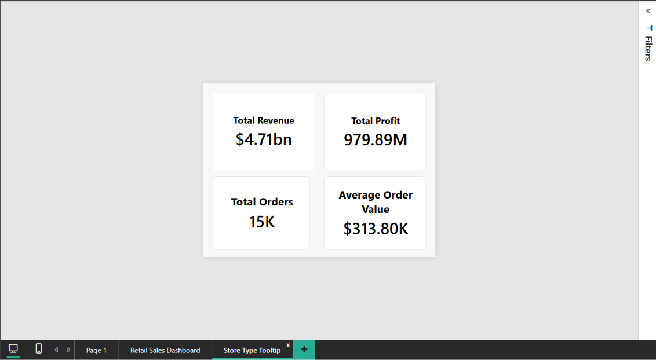
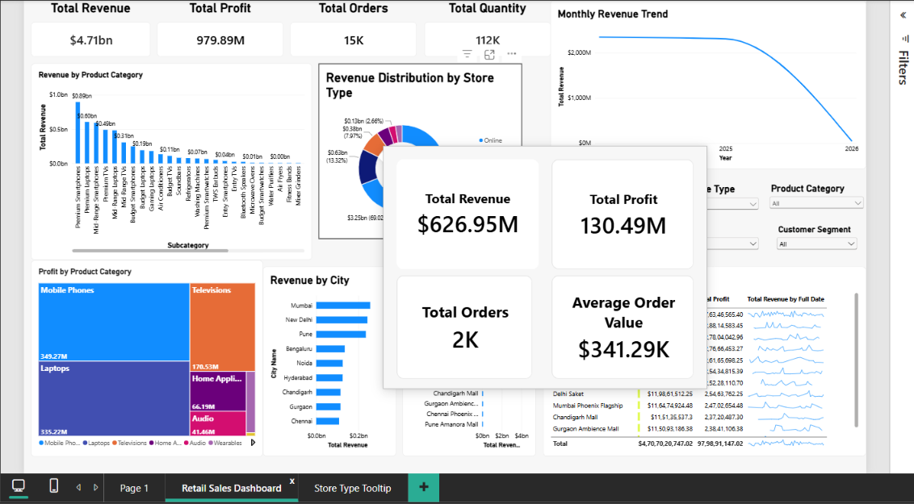
Key Findings
- Overall Sales Performance: The Total Revenue and Total Profit KPI cards provide a quick overview of the business's financial performance.
- Product Category Performance: The revenue chart and profit treemap help identify which product categories contribute more to revenue and profitability.
- Store Performance: The store-wise revenue chart allows users to compare sales across different stores and identify variations in performance.
- Monthly Revenue Trend: The line chart helps track changes in revenue over time and observe potential seasonal patterns.
- Revenue by Store Type: The donut chart shows the proportion of total revenue contributed by different store types.
- Geographical Sales Performance: The city-wise revenue chart helps compare sales across locations and identify areas with stronger or weaker revenue contributions.
- Order and Quantity Analysis: The Total Orders and Total Quantity KPI cards summarise order volume and the number of products sold.
- Interactive Analysis: The slicers allow users to filter data by product category, store, customer segment, salesperson, year, month, state, city, and store type, making it easier to investigate specific business segments.
Conclusion
This project shows how Power BI can turn a compact budget spreadsheet into a practical performance report. Comparing budget and actual results makes it easier to see that revenue was slightly below plan overall and that actual profit fell short of budget by ₹107,500 for the three-month period. The monthly charts and KPI cards help reveal where performance differed from expectations, while a cost comparison can point managers toward the cost categories that need attention. The conclusions are limited to the three months and fields included in the supplied dataset.
Reference
- Microsoft Power BI Desktop.
- Dataset 6 – ABC Manufacturing Budget Variance Dataset.xlsx
- Microsoft Learn – Power BI documentation.

